Urban unemployment rate at 9.62%, rural 7.15%: BSE index
PTI Apr 7, 2016, 06.13PM IST
NEW DELHI: The unemployment rate in urban areas stood at 9.62 per cent, much higher than the 7.15 per cent in rural pockets, says a BSE index.
The overall figure for the country is 7.97 per cent, the index prepared by the top stock exchange BSE in collaboration with business information firm CMIE showed.
The index is based on responses from over 1.30 lakh individuals in about 39,600 households spread across 315 cities and 3,000 villages in India.
As of April 6, the jobless rate (urban) stood at 9.62 per cent while that of rural areas was 7.15 per cent, the index showed.
In the second half of February, the urban unemployment rate crossed the 10 per cent mark while the corresponding figure for rural areas hit 5.82 per cent in the second half of January.
The data, which were recently launched by BSE, are the first instance of a non-governmental organisation producing an unemployment measure for any country in the world.
Earlier this month, BSE had said it would also bring out state-wise unemployment rates in a few months.
Commentary:
As of April 6, 2016, the unemployment rate (UR) in India stood at 9.79%. The UR in urban areas was at 9.62% while in rural areas, it was measured at 7.15%, according to BSE and CMIE. Unemployment Rate refers to the number of people who are part of a country’s workforce, actively seeking and willing to work but are unemployed. There is a substantial difference in the UR between rural and urban areas in India.
Unemployment exists in rural areas since India is an agrarian economy and does not provide employment all year round, leading to seasonal unemployment and in harvesting season, more workers are engaged than required for production, leading to disguised unemployment.
However, there are various factors for a higher UR in urban areas compared to rural areas, a main reason being cheaper technology and technological advancements making workers redundant. Over the years, technology is advancing and is becoming cheaper, and because of the advantages of technological automation, many businesses replace employees with advanced machinery (known as technological unemployment – Unemployment resulting from technological changes in an industry), although in rural areas, capital investment in advanced technology is unaffordable and less available than in urban areas, meaning than technological unemployment is lower in rural areas.
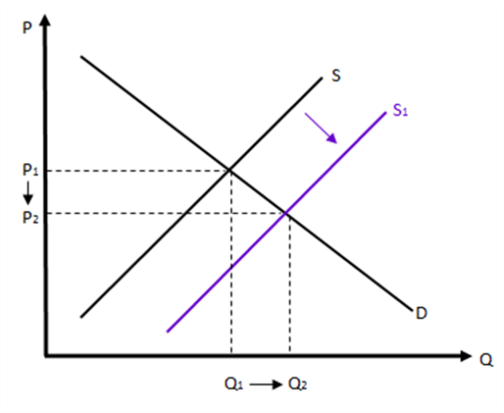
Another major reason why the UR is higher in urban areas than rural areas is migration of workers from rural to urban areas. This happens because usually urban areas offer better standards of living, such as better education and healthcare, better job opportunities and higher wages. This migration causes excess supply of labour meaning labour supply exceeds quantity demanded in urban India. Therefore, in the short-run, the UR will rise due to frictional unemployment (when workers are temporarily unemployed while moving from one job to another or looking for a job). Nevertheless, India being one of the world’s emerging and fastest growing economies, in the long-term, businesses will expand, production will rise from Q₁ to Q₂ (Figure 1) leading to a lower UR.
Figure 1: Effect of an increase in labour supply
One major risk of a high UR is that the Indian government may end up borrowing even further and reach unsustainable levels as it already is in high debt. This is because fewer people would be eligible to pay taxes as they are not being employed hence earn no income, resulting in lower tax revenues for the Indian government. In order to keep up with planned spending, the Indian government may have to borrow money to fund the spending.
However, unemployment can be solved using fiscal or monetary policies, for example increasing the number of jobs through fiscal and expansionary policies. In the case of fiscal policy, if income taxes were reduced and government spending increased, people would have higher disposable incomes, hence increased consumer spending. This means that Aggregate Demand (AD) increases, causing higher production of goods and services to fulfil the increase in AD. To enable increased level of production, more workers need to be employed; hence there is incremental job creation and reduction in unemployment. This will also have a positive effect on GDP growth. Likewise, through an expansionary monetary policy, interest rates reduce and money supply increases. This acts as an incentive for people to borrow more money, since saving will not give high returns and borrowing happens at lower interest costs. This again increases their disposable incomes, spending and AD, which eventually causes additional job creation and reduction in unemployment.
Figure 2: Effect of a higher UR on Real GDP (in urban areas) on Keynesian AS curve
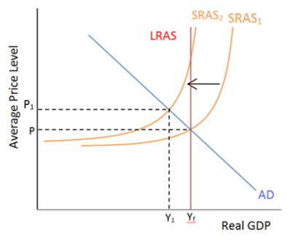
In the short term, as seen in Figure 2, due to high unemployment, the SRAS₁ curve will shift inwards to SRAS₂, resulting in a lower GDP from Y_{f} to Y₁ and a higher average price level from P to P₁. Thus, there is a contraction in AD. However, in the long-term, expansionary fiscal and monetary policies will benefit the Indian economy, shifting the Long Run Aggregate Supply (LRAS) curve to the right, although the significance of this benefit depends on the multiplier effect (the increase in final income arising from any new injection of spending). The LRAS curve will eventually return back to the potential real GDP (Y_{f}) from Y₁ in the long-term.
Another way the Indian government could decrease unemployment rates is through supply side policies, like subsidies and grants. Although this would mean that government expenditure would rise, it would aid local businesses to increase production meaning firms must employ more workers resulting in the UR in India reducing. Despite this, there will still be a natural rate of unemployment (lowest UR an economy can sustain over the long run).
Bibliography:
Books:
- Tragakes, ET, 2012. Economics for the IB Diploma. 2nd ed. Edinburgh, Cambridge: Cambridge University Press.
Websites:
- Difference Between Urban and Rural India | Difference Between. [ONLINE] Available at: http://www.differencebetween.net/miscellaneous/difference-between-urban-and-rural-india/. [Accessed 28 February 2017].
- In India, unemployment rate still high - The Hindu . [ONLINE] Available at: http://www.thehindu.com/news/national/in-india-unemployment-rate-still-high/article7851789.ece. [Accessed 28 February 2017].
- Urban unemployment rate at 9.62%, rural 7.15%: BSE index - The Economic Times. [ONLINE] Available at: http://economictimes.indiatimes.com/news/economy/indicators/urban-unemployment-rate-at-9-62-rural-7-15-bse-index/articleshow/51729670.cms?intenttarget=no. [Accessed 28 February 2017].
- YourArticleLibrary.com: The Next Generation Library. The Causes of Unemployment at Urban Areas in India. [ONLINE] Available at: http://www.yourarticlelibrary.com/unemployment/the-causes-of-unemployment-at-urban-areas-in-india/4705/. [Accessed 28 February 2017].
- YourArticleLibrary.com: The Next Generation Library. The Following Types of Unemployment Exist in India. [ONLINE] Available at: http://www.yourarticlelibrary.com/economics/the-following-types-of-unemployment-exist-in-india/2760/. [Accessed 28 February 2017].
- Labor force, total | Data. [ONLINE] Available at: http://data.worldbank.org/indicator/SL.TLF.TOTL.IN?order=wbapi_data_value_2014+wbapi_data_value+wbapi_data_value-last&sort=asc. [Accessed 28 February 2017].

“Urban unemployment rate at 9.62%, rural 7.15%: BSE index - The Economic Times” Accessed 28 February 2017: http://articles.economictimes.indiatimes.com/2016-04-07/news/72132533_1_unemployment-rate-bse-cent.
A type of economy that relies mainly on its agricultural industry
Refers hen a part of the labour force is either working in a redundant manner or not working at all, resulting in low productivity.

